

# Software Design Specification

# For FreeEDR

## Version 3.0.0 approved

#### Prepared by:

|  |  |  |
| --- | --- | --- |
| Bryan Bolesta | Ryan Fiers | Declan Kelly |
| Matthew Horger | Layla Phills | Zachary Santoro |
|  | Marisa Tranchitella |  |

Team FreeEER

April 26, 2020

**Contents**

1 Introduction 4

1.1 Scope 4

1.2 Definitions, Acronyms, and Abbreviations 4

1.3 Requirements Traceability Matrix 4

2 Architectural Description 7

3 Interface Description 9

3.1 User Interface 9

1. Home 9

2. Reporting 9

3. Audit 9

4. Support 9

5. Admin 10

3.2 Data Interface 10

3.3 Application Interface 11

4 Detailed Design 11

4.1 DE1.1 Dashboard 11

4.2 DE1.2 Permissions Matrix View 14

4.3 DE1.3 Rule Storage Server 14

4.4 DE1.4 Permissions Matrix File 15

4.5 DE1.5 Correlation Rule Repository 15

4.6 DE1.6 Event Log 15

4.7 DE1.7 Network Log 15

4.8 DE1.8 Custom Windows Event Log 16

4.9 DE1.9 Internal API’s 16

4.10 DE1.10 Endpoint Rule Request & Process Script 18

# Introduction

## Scope

Many corporate organizations lack the budget or resources to protect their employee’s workstations from vulnerabilities and threats. FreeEDR is an open-source endpoint detection and response system for small infrastructure teams and organizations to utilize free of charge. FreeEDR, in conjunction with Security Risk Advisors, will connect itself with threat intelligence sources to provide a comprehensive solution for endpoint security for these organizations.

## Definitions, Acronyms, and Abbreviations

* + 1. AD: active directory, a package of special services to manage permissions and resources on Windows workstations
    2. API: application programming interface, technology used for transmitting data between sources such as clients, servers, databases, etc.
    3. EDR: also known as endpoint detection and response, a technology used to address the needs for continuous coverage against advanced threats
    4. Forensic Information: information not included in an event, that assists with analysis. For example, IP address’, process ID’s, file hashes, trust scores, etc.
    5. GPO: group policy object, used when policy settings need to apply to multiple Windows workstations
    6. Sigma: generic, open signature format that allows relevant log events to be reported in a straightforward manner
    7. SigmaC: tool used to translate Sigma format rules to the language of choice
    8. SIEM: Security Information and Event Management
    9. SIRT: Security Incident Response Team
    10. SOC1: also known as a system and organization controls report, used for making sure an organization’s internal control procedures are being properly followed.
    11. Threat Intelligence Sources: security feeds from vendors, government / public, and private sources that provide information about known IT vulnerabilities and risks for organizations.
    12. QA: Quality Assurance

## Requirements Traceability Matrix

This section maps the relationship between requirement statements and detailed design entities. As such it shows how requirements are covered by the design, and demonstrates the purpose for which design entity exists.

The values in the cells of the table show which requirements provide the purpose for each entity. The cell values are:

* Blank – the design entity does not implement any of that requirement
* P for Primary - the design entity implements all or most of the requirement
* S for Secondary – the design entity implements a smaller but essential part of the requirement

|  |  |  |  |  |  |  |  |  |  |  |
| --- | --- | --- | --- | --- | --- | --- | --- | --- | --- | --- |
|  | **DE1.1** | **DE1.2** | **DE1.3** | **DE1.4** | **DE1.5** | **DE1.6** | **DE1.7** | **DE1. 8** | **DE1.9** | **DE1.10** |
| **R1.1** |  |  | S |  | P |  |  |  |  |  |
| **R1.2** |  |  |  | P |  |  |  |  |  |  |
| **R1.3** |  |  | S |  |  |  |  |  |  |  |
| **R1.4** |  |  |  | P |  |  |  |  |  |  |
| **R1.5** |  |  |  | P |  |  |  |  |  |  |
| **R2.1** |  |  | S |  |  |  |  |  | P | P |
| **R2.2** |  | S |  |  |  |  |  |  |  |  |
| **R2.3** |  |  |  |  |  | S |  |  | P | P |
| **R2.4** |  |  |  |  |  |  |  |  | P |  |
| **R2.5** |  |  |  |  |  |  |  |  | P |  |
| **R2.6** |  |  |  |  |  | S | S | P |  |  |
| **R2.7** |  |  |  |  |  |  |  |  | P |  |
| **R2.8** |  |  |  |  |  |  |  |  | P |  |
| **R2.9** |  |  |  |  |  |  |  | S |  | P |
| **R3.1** |  |  | S |  |  |  |  |  |  |  |
| **R3.2** |  | P |  |  |  |  |  |  |  |  |
| **R3.3** | P |  |  |  |  |  |  |  |  |  |
| **R3.4** | S | P |  | S |  |  |  |  |  |  |
| **R3.5** | P |  |  |  |  |  |  |  |  |  |
| **R3.6** | P |  |  |  |  |  |  |  |  |  |
| **R3.7** | P |  |  |  |  |  |  |  |  |  |
| **R3.8** | P |  |  |  |  |  |  |  |  |  |
| **R3.9** | P |  |  |  |  |  |  |  |  |  |
| **R4.1** |  |  |  |  |  | P | P |  |  |  |
| **R4.2** |  |  |  |  |  |  |  | S | P |  |
| **R4.3** |  |  |  |  |  |  |  | S | P |  |
| **R4.4** |  |  | S |  |  | P | P |  |  |  |
| **R4.5** |  |  |  |  |  |  |  |  | P |  |
| **R4.6** | S |  |  |  |  |  |  |  |  |  |
| **R4.7** | P |  |  |  |  |  |  |  |  |  |

# Architectural Description

FreeEDR operates on a client-server foundation and has version dependencies on each aspect of the architecture.

The client workstations within FreeEDR meet the following specifications;

* Operating System: Windows 7 - Windows 10
* Security Restrictions: None, PowerShell script may be run to query Windows Event Log

The servers within FreeEDR meet the following specifications;

* Operating System: Windows 2016, version 1607
* IIS: 10.0
* Results Communication tool: Microsoft Exchange O365

For the purposes of abstracting off information, the two diagrams presented below represent interactions between the clients internally and their dependencies on the server, as well as the actions performed by the server separately from the client.

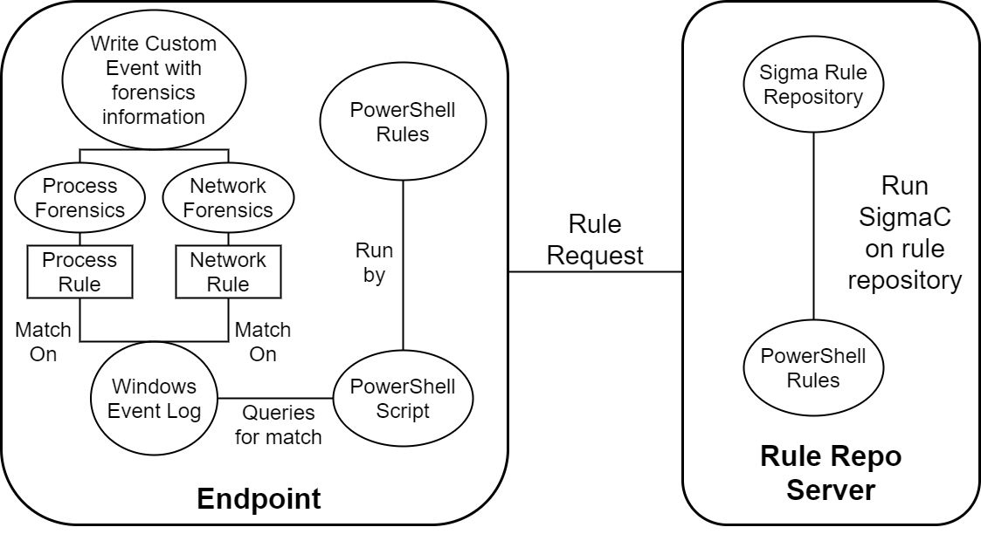

*Figure 1 Rule Repository Server Communication with Endpoints*

In this diagram, the client which is represented as an endpoint is detailed on the left side while the server which stores the rules repository is located on the right. On the server side, PowerShell rules execute SigmaC on the Sigma Rule Repository object. The client then will request for any rules from that server upon the client doing the analysis. On the client side, these PowerShell rules are run to query for a match based on what event is produced on the client’s workstation. FreeEDR gathers custom event information, categorizes the event either as a process or a network event, and then performs forensics on the event. Depending on the result of forensics, our process and network rules then write the information to be stored out to a custom Windows Event. By abstracting process and network categories to perform certain rules, this procedure allows for the FreeEDR to provide more detailed forensics information for the custom event.

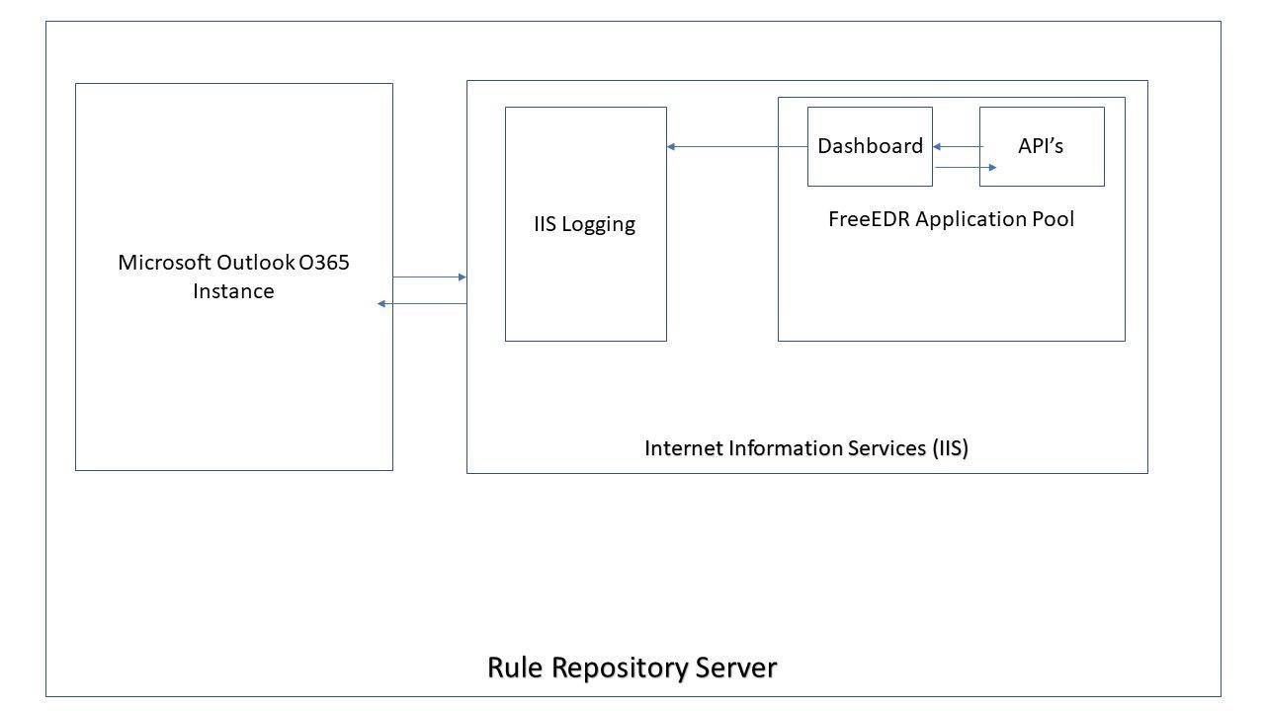

*Figure 2 IIS Configuration for Dashboard / other API’s*

In order for our internal application endpoints to communicate within FreeEDR, IIS must be set up on the same server as the rule repository storage object. In IIS, we must have an application pool dedicated to serving up applications assigned to a specific Active Directory user. By having both the Dashboard and API assigned to a specific AD user, FreeEDR is able to easily monitor all endpoints and traffic to the instances via %systemroot%\system32\logfiles for that specific user. Our application pool connects to the built-in IIS logging system that Dashboard Infrastructure managers are able to view in case there are any issues with the product. Finally, the IIS instance running on the Windows server is able to connect to a Microsoft Outlook O365 instance, provided that the Dashboard Infrastructure Manager configures the Exchange Web Service (EWS) autodiscover url in the app.config section of every API and Dashboard deployment. A sample autodiscover url is one like so:

[*https://mail.domain.com/ews/exchange.asmx*](https://mail.domain.com/ews/exchange.asmx)

By having the autodiscover URL in the app.config, the Dashboard is independent of changes to the EWS instance and only relies on a single entrypoint, rather than having multiple dependencies within the code itself and relying on emergency redeployments every time the O365 instance changes.

# Interface Description

## User Interface

The system’s user interface will display information in a dashboard format coded in React with component implementations from Google’s Material UI and MUI Datatables. The dashboard is sectioned off into 5 distinct sections.

### Home

The Home page is intended to display a custom data view where clients can see what reporting information is important to each respective user. The home page will rely on an internally developed engine to filter specific reports and information to allow for users to pick and choose data grid views. Some of the visual aids that will be implemented are tabular, bar charts, and typical XLSX graphs.

### Reporting

The Reporting page is intended for Incident Response team members to ensure that security alerts are being properly reviewed, responded to, and analyzed. This page is critical for Incident Response team members as they are able to view all the reports they can generate to see what events are happening more or less frequently and adapt their practices to adjust for these client actions. The reporting page has the following report options; each will offer a destination for the report to be sent or saved to.

* Security Event Log - This report generates a list of all security
* events throughout all of FreeEDR. This report can be generated daily, weekly, or for any historical period.
* User Event Log - This report generates a list of all security events
* produced by a client endpoint. This report, like most, can also be generated for a given span of time.
* Process / Network Event Log - This report generates a list of all
* process or network security events depending on a user’s selection.
* Trend Log - This report generates a historical model of when security events are triggered.

### Audit

The Audit page is intended for system auditors to have view access of all system and user logs, as well as perform historical and up-to-date tasks when performing auditing procedures. The primary function of the audit page is to allow for system auditors to generate audit reports within a given period of selected time in order to ensure that the system is compliant and all best practices are being followed. The audit page also produces views that system auditors see when previous SOC1 reports were generated and view historical trends of when audits were performed. This audit page is customizable so that certain auditors in a team may have ease of access to generate reports that they normally are assigned to.

### Support

The Support section is intended for users of the dashboard to seek help when the dashboard is not functioning properly, or data seems invalid. There are three key components to the support section:

* Contact Incident Support - This page is intended to provide
* information a workstation employee would need to get in touch with an Incident Support member. This will be a listing for their office number. End users should use this page when they suspect they have encountered a critical security issue.
* Support Hotline - This page is intended to allow users to contact a
* member of the Dashboard Infrastructure team if they suspect something is wrong with the FreeEDR system. This includes, but is not limited to, invalid data, permissions, and operation functionality.
* Submit a Ticket - This page is intended to allow users to request
* new features for the dashboard, or ask general inquiry questions for the support team.

### Admin

The Admin section is intended solely for support staff of the dashboard, which includes Incident Support and Dashboard Infrastructure team members. There are two key components of the admin section:

* Permissions Matrix - This page is intended for Dashboard. Infrastructure support members to be able to view, add, and remove access permissions for users in regards to the dashboard itself. The matrix itself will be built inside a MUI Datatable to allow for support members to grant access remotely via a mobile browser.
* View Rule Repository - This page is intended for Incident Support. Managers to quickly view the rule repository and the secured contents. This page does not have any functionality to modify the rule repository or contents, as those changes must be made external of a front-facing application.

## Data Interface

FreeEDR accepts certain files from external third-party threat intelligence sources. The file is classified as a Threat Intelligence Rule, and has a strict classification of a data type. These files are YAML files which contain rule logic in an expected

Sigma format for our system to process. These Threat Intelligence Rules are then stored in FreeEDR’s Rule Repository which are then translated to PowerShell queries to be executed.

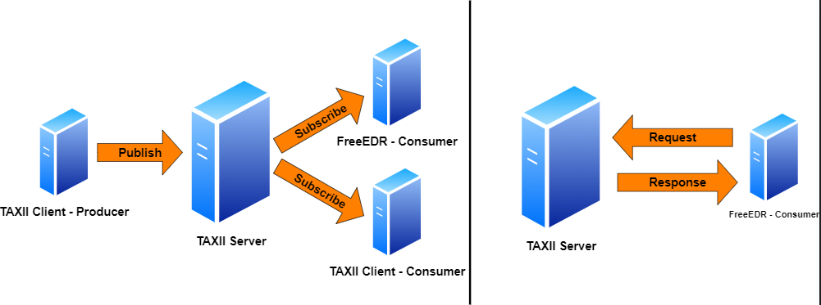

*Figure 3 A simple diagram showing the interactions between TAXII and Clients. FreeEDR is a consumer of information from a TAXII server and makes requests to fetch information.*

## Application Interface

FreeEDR utilizes TAXII (Trusted Automated eXchange of Indicator Information), which is a free and open transport mechanism that standardizes the automated exchange of cyber security and risk information. FreeEDR makes requests to a TAXII server in order to pull down STIX (Structured Threat Information Expression) data. This application interface allows for TAXII to determine where to store this Threat Intelligence Rules so that FreeEDR can process the data interface above.

# Detailed Design

## DE1.1 Dashboard

**Type:** Screen

**Description:** The dashboard is the home screen of FreeEDR's user interface. Here, all workstation employees are able to navigate to four different action categories via a slide drawer on the left side. The home page itself must include a table of recent reports that all user roles except general workstation employees can view and download files.

The first action category is Reports. In this category, support managers and dashboard infrastructure managers are able to customize what reports they are able to see when they first visit a page. In a series of tabs, they are able to see the logs of report generations, when rules were deployed, and generate a series of event reports given a specific target of interest (application, security, setup).

The second action category is Audit. In this category, audit managers are able to view and generate particular SOC1 and internal controls reports. In the same series of tab structures, they are able to view previous audits for historical information.

The third action category is Support. In this category, workstation employees are able to contact members of the Support Incident team. All of the support team’s information is present on this page, as well as an option for all users except workstation employees to submit a new feature request to be added to the dashboard.

The fourth action category is Admin. In this category, dashboard infrastructure managers are able to view what active directory groups within FreeEDR have access to specific elements of the Dashboard, such as report generation, report viewing, etc. Dashboard infrastructure managers are also able to view the details for the rule repository in case they forget the connection details.

**Mockups:**

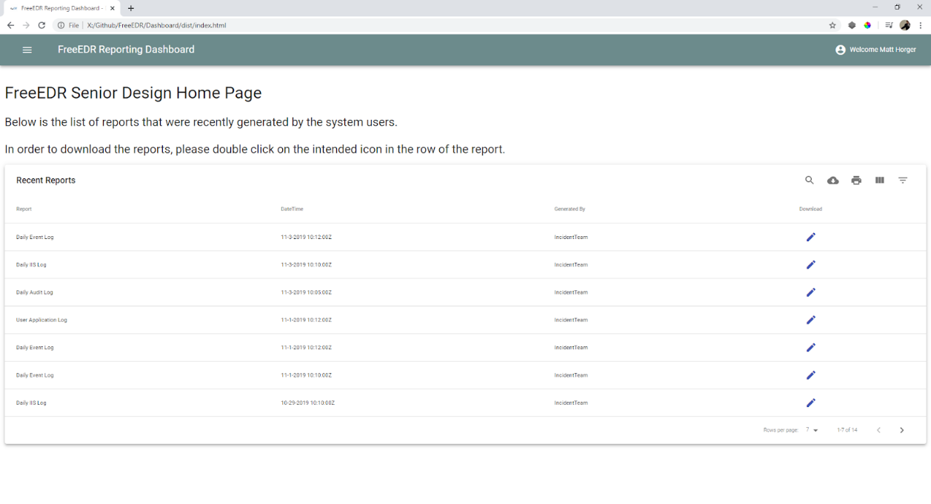

*Figure 4 This screen represents the initial Dashboard landing page. In the top right-hand corner presents the name of the user accessing the dashboard.*

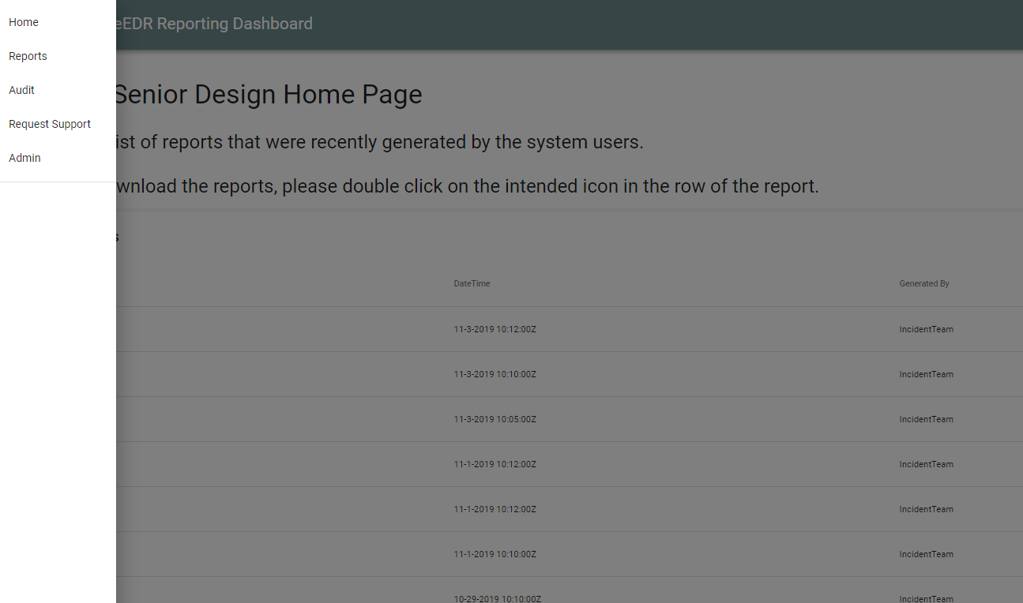

*Figure 5 This mockup demonstrates the drawer functionality for the menu dashboard by clicking on the hamburger menu icon in the app dashbar (colored in shale green). All workstation employees will have read access to this page, but will be unable to target certain options based on the permissions matrix (e.g. Admin).*

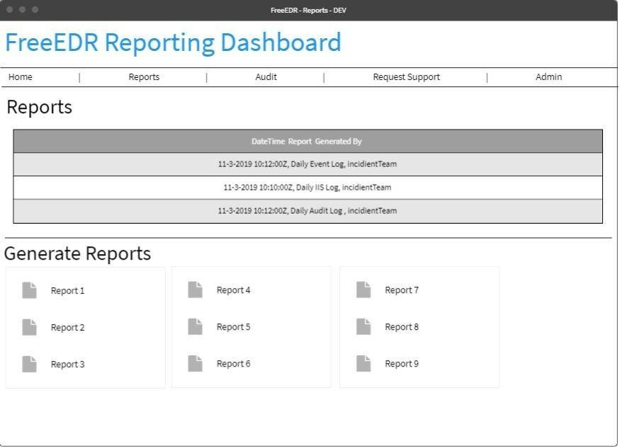

*Figure 6 This mockup represents the ability for Incident Response members to see recently generated reports, as well as the option to trigger the generation for new reports.*

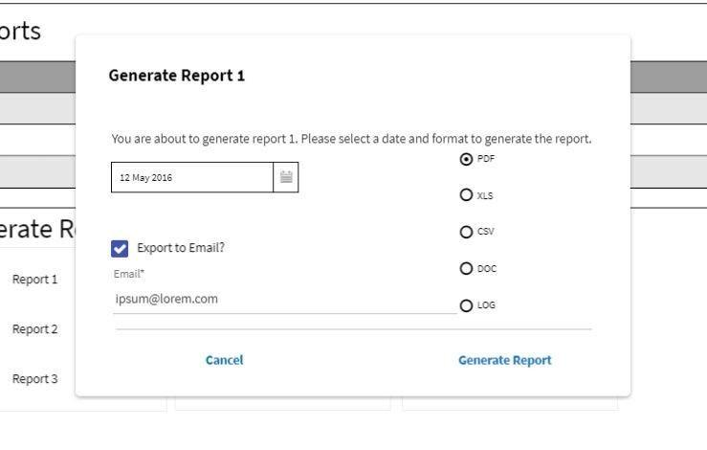

*Figure 7 This mockup represents the dialog box presented to Incident Response members when they want to generate a report. Date range is only available for specific reports and not listed here.*

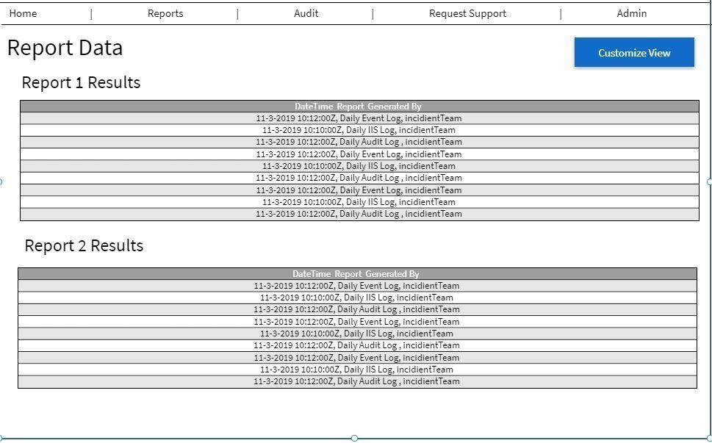

*Figure 8 This mockup shows the tabular customization result for a Incident Support Member to customize their reporting home data view. Other options include bar graphs and other React-MaterialUI possibilities. Tabular is shown here as a limitation of the mockup design software.*

## DE1.2 Permissions Matrix View

**Type:** Screen

**Description:** The permissions matrix view will be accessible from the dashboard screen and will allow the dashboard infrastructure manager to view and adjust active directory permissions for the Dashboard components within FreeEDR.

**Mockups:**

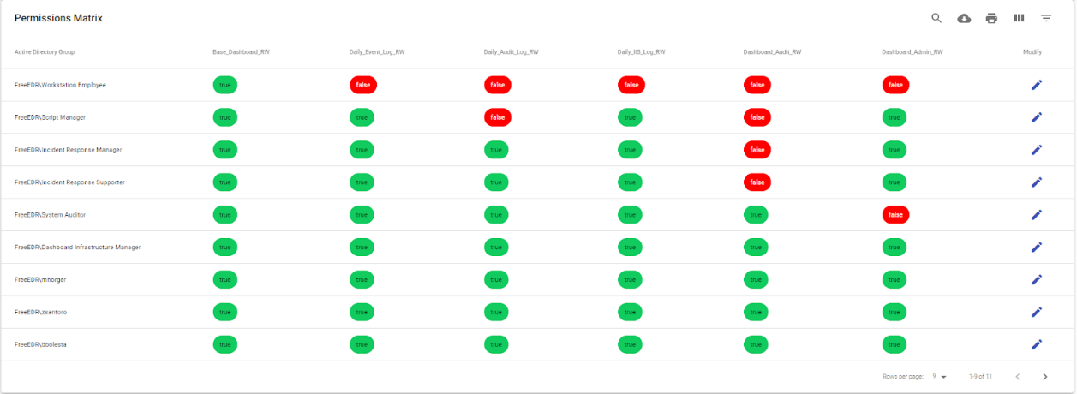

*Figure 9 This mockup shows the permission matrix that can be customized for FreeEDR security roles. The columns include the active directory group, and each specific security role granted to that particular user. For example, the first row symbolizes that Workstation Employees can only access the dashboard for the support tab, but cannot see any logs or access the audit / admin tabs.*

## DE1.3 Rule Storage Server

**Type:** Microsoft Windows Server

**Description:** The server that stores all rule data objects. This server also hosts the Dashboard and API’s in IIS. This server should be domain joined with the endpoint machines that FreeEDR is being deployed to. The server will use a supported version of Microsoft Windows Server O/S, such as Windows Server 2012 (64-bit). This server will be allocated at least 40GB of Storage and 4096MB of Memory to be able to store all rule data objects, dashboard objects, and API’s.

## DE1.4 Permissions Matrix File

**Type:** Data File

**Description:** The file that stores the permissions that the dashboard infrastructure manager maintains. This file is leveraged by the dashboard in order to properly grant access to certain components based on the contents.

**Format:** JSON

**Structure:** [ {“$permission$”: {“$AD_Group$”: “active”, “$AD_GROUP$: “inactive”}, {“$permission$”: {“$AD_Group$”: “active”, “$AD_GROUP$: “inactive”}]

## DE1.5 Correlation Rule Repository

**Type:** Data Repository

**Description:** The correlation rule repository houses rules. Rules can contain the following attributes: title, status, description, author, references, logsource, detection, false positives and level. These attributes are customizable. The rules stored within the correlation rule repository will be stored as YAML (.yml) files. The repository itself is stored on the rule storage server.

## DE1.6 Event Log

**Type:** Data File

**Description:** The event log records all captured events generated by IIS functions. The attributes for an event include: event, event type, event ID, source, log location, data and time, task category, keywords, computer, user, opCode and more information provided by Windows in the scenario that it has more information to dump.

## DE1.7 Network Log

**Type:** Data File

**Description:** The network log stores data that is created when traffic occurs between clients and IIS operations. Network records contain the following attributes: name of machine, user account, date time of request, IP address, HTTP response status code, headers, requested IP addresses and number of packets transmitted.

## DE1.8 Custom Windows Event Log

**Type:** Data File

**Description:** The custom Windows Event is a Windows Event that has been enriched with forensics data for the process or network connection. The forensics information specifies how trustworthy the process or network connection is. The forensics information for the relevant process or network event is retrieved from the process and network forensics APIs and added to the Custom Windows Event Log to enrich the information provided by the log.

## DE1.9 Internal API’s

**Type:** C# WCF RESTFUL API

**Description:** In order to satisfy requirement R3.1, FreeEDR will provide an API written in C# and protocoled in Windows Communication Foundation (WCF) in order to transmit data between the dashboard and rule repository.

* This API will be exposed via RESTFul calls instead of the default SOAP configuration set by WCF
* This API must be deployed on an Internet Information Service (IIS) instance in order to assign a service account for security access. This service account is what the Dashboard Infrastructure Manager will use to allow users to view specific reports and actions via requirement R3.5.
  + Endpoints
    - GetReportOptions()
      * This endpoint will return the list of report options that can be generated.
    - GetHistoricalReports(DateTime dt)
      * This endpoint takes in a date time object and returns the reports generated for the given date.
    - GetReport(Report r)
      * This endpoint generates a given report object for the current date in the default format of PDF.
    - GetReport(Report r, DateTime dt)
      * This endpoint is an overload of the default endpoint to generate a report object. This endpoint allows for reports to be regenerated for previous dates.
    - GetReport(Report r, FormatObject f)
      * This endpoint allows for users to specify which format they want their requested report object to be returned as with the default date.
    - GetReport(Report r, DateTime dt, FormatObject f)
      * This endpoint allows for users to specify which format and date they want their requested report object to be returned as.
    - GetReportRange(Report r, DateTime start, DateTime end)
      * This endpoint generates a list of reports of a given report object within a start and end date.
    - ExportReport(Report r, string recipient)
      * This endpoint forwards a generated report to a requested email address.
* In order to satisfy requirement R3.7, FreeEDR must supply a MailService API that restricts sending reports externally to recipients
  + This API corresponds with the report generation API in that it is a connected service referenced.
  + This API will be connected using Microsoft Outlook O365 to provide the
  + capacities to send emails.
  + This API must be configured with an organization’s auto discover URL in order to properly connect to the running instance.
  + Endpoints:
    - SendMail(string sender, string recipient, string subject, string message)
      * This endpoint will send a specific HTML mail message from the requested sender to the recipient.
      * This recipient parameter could take in multiple contacts separated by a comma.
    - SendMail(string sender, string recipient, string subject, string message, string attachment)
      * This endpoint is an overloaded endpoint that allows for an option to send an attachment.
      * The attachment must be a valid folder path.
      * The attachment must be accessible by the service account assigned to the application pool in IIS.
      * The attachment must not be larger than Outlook’s size requirements (>10mb).
* In order to satisfy requirements R3.8 and R3.9, FreeEDR will implement a ‘heartbeat’ API for the dashboard to utilize.
  + This API will be written on a low-level scale in order to promote fast response times to fetch new data requests.
  + This API needs to be separate from the other main API in order to not spawn multiple concurrent resource allocations which will drawback from performance.
  + Endpoints
    - CheckAlive()
      * This endpoint checks to make sure the heartbeat service is alive.
    - FetchData()
      * This endpoint checks to make sure that there is no fresh data that needs to be populated before a report is generated.
    - Restart()
      * This endpoint forces all concurrent connections to drop communication.

## DE1.10 Endpoint Rule Request & Process Script

**Type:** PowerShell Script

**Description:** The endpoint rule request script will be assigned to each endpoint. Its purpose is to reach out to the rule repository and request any new rules and store them in C:\FreeEDR. Then, it runs the rules to see if there is a matching windows event. If the rule matches on a process event, then the script will gather forensics information about the specific process. If the rule matches on a network event, the script will gather forensics information about the network connection.